ANZICS Person with Lived Experience Position Description

Position Purpose
The Australian and New Zealand Intensive Care Society is devoted to all aspects of intensive care. Our vision is to connect the intensive care community and to make tangible contributions to the specialty of intensive care for the benefit of patients, families, and clinicians. As a member of the Community Engagement Registry, your role will help us capture the voice of patients and carers, allow us to listen to your unique and crucial points of view and help us incorporate these into decision-making.
Levels of engagement
Researchers, registry users and clinicians may ask for you to be involved in some or all of the levels outlined below.
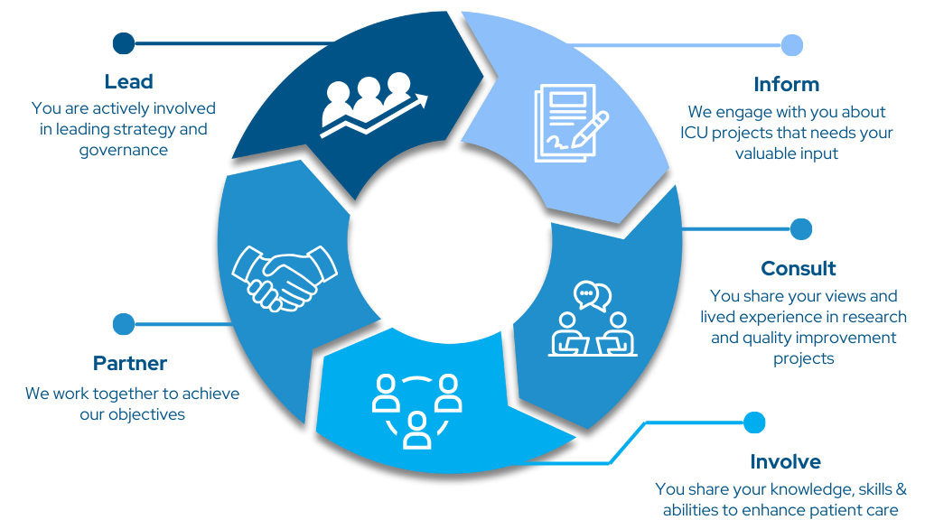

Inform | As a person with lived experience, you will receive study information on research and quality improvement projects.
Consult | Clinicians /researchers may consult with you to understand your views on a particular topic. This may include surveys, focus groups, meetings or interviews.
Involve | You may review and provide feedback on the development of materials (protocols, posters, communications etc) for a program of work.
Partner | We work together to achieve the project objectives through information sharing, networking, communication and collaboration.
Lead | You are actively involved in leading strategy and governance of all projects, studies and manuscript preparation.

Roles & Responsibilities:
- Actively communicate with researchers and project leads throughout the project or body of work.
- Actively participate in surveys. Interviews and other activities as required
- Undertake background reading when required
- Declare any potential conflicts of interest if/as they arise.
- Maintain confidentiality and privacy.
- Maintain a log of your hours of participation, get this signed by your project lead and retain any receipts for Taxation claims.
Our Requirements:
Each Person with Lived Experience is required to sign an Engagement Agreement, Confidentiality Agreement and Remuneration Agreement to become member of the Community Engagement Registry. These agreements outline appropriate conduct with others, the need to maintain confidentiality and declare any conflicts of interest. A breach of any of these may result in your involvement with the Registry being terminated.
Qualifications:
There are no set educational or professional requirements for this role. We would like a diverse range of participants from different professions and varying levels of education and ethnicity to reflect the wider community.
Equality & Inclusion:
ANZICS is an equal opportunity employer committed to providing a workplace free from any unlawful discrimination, harassment or bullying. This role is open to people who have previously been a patient in the Intensive Care Unit or had a loved one admitted to the Intensive Care Unit in Australia or New Zealand. We particularly encourage Persons with Lived Experience from minority groups and those that are often underrepresented to participate. If you have any special requirement for your active participation please let us know in the EoI form. This will not exclude you, rather allow us to better support you in the role.
Term:
This role does not have a set term. Your involvement is voluntary and ongoing at your own discretion. As a Person with Lived Experience, you can leave the Community of Practice at any time. ANZICS does however, review its policies and practices every three years. As such we may update or refine our paperwork and aspects of the role. This will always be communicated to you should changes or improvements need to be made.

